Experiment-3
Design of IIR Filters Using Impulse Invariance and Bilinear Transformation Methods Using MATLAB
CO Mapping:CO1
Blooms Level K5-Evaluate
WK Level :WK4- Engineering Design (Evaluates alternative filter designs against specifications)
➔ Major Topic
Digital IIR Transformation
➔ Minor Topics
Analog-to-digital conversion, impulse invariance, bilinear transformation, frequency warping, prewarping
➔ Objectives of this Experiment:
1. To convert a suitable analog IIR prototype into a digital IIR filter using impulse invariance.
2. To convert the same prototype using the bilinear transformation method.
3. To investigate frequency warping and the need for prewarping in bilinear transformation.
4. To compare the digital filter coefficients and frequency responses obtained using both methods.
➔ Expected Outcome from this Experiment:
Students shall be able to:
1. Obtain digital IIR filter coefficients using impulse invariance and bilinear transformation.
2. Generate and compare the frequency responses of the two transformed filters.
3. Identify frequency-warping effects and demonstrate the role of prewarping.
4. Interpret the differences between the two transformation methods using response plots and numerical parameters.
➔ Software Required:
MATLAB with Signal Processing Toolbox.
➔ Objective linkage:
The experiment is structured so that each objective directly produces a verifiable output listed in the Output Parameter Table.
➔ Experimental Procedure:
1. Specify an analog low-pass prototype and its sampling frequency.
2. Obtain the analog filter transfer function or coefficients.
3. Apply impulse invariance to obtain the digital numerator and denominator coefficients.
4. Apply bilinear transformation, with prewarping when required, to obtain the second digital filter.
5. Plot magnitude and phase responses for both digital filters on a common frequency axis.
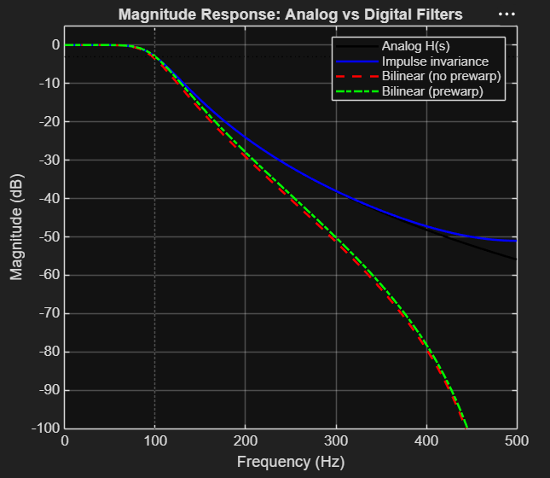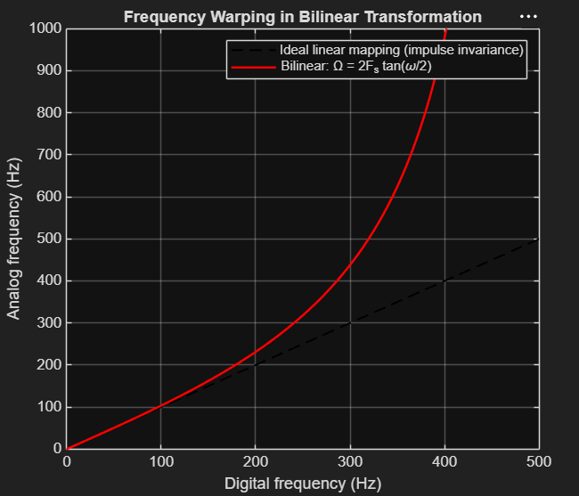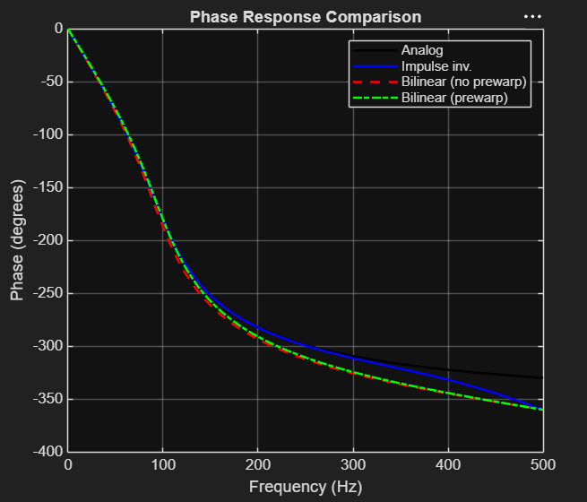

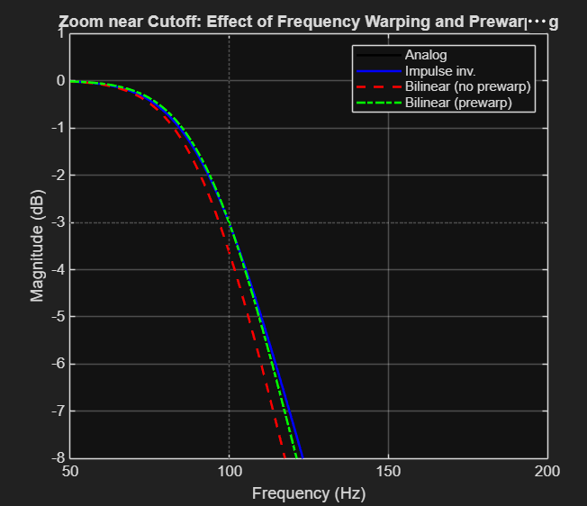
%% Experiment 3: Impulse Invariance vs Bilinear Transformation
clc; clear; close all;

%% 1. Specifications and analog prototype
Fs = 1000; % Sampling frequency (Hz)
fc = 100; % Analog cutoff (-3 dB) frequency (Hz)
N = 4; % Prototype order
Wc = 2*pi*fc; % Analog cutoff (rad/s)

[ba, aa] = butter(N, Wc, 's'); % Analog Butterworth LPF H(s)

disp('--- Analog prototype H(s) ---');
disp('Numerator ='); disp(ba);
disp('Denominator ='); disp(aa);

%% 2. Method 1: Impulse invariance
[bz_ii, az_ii] = impinvar(ba, aa, Fs);

%% 3. Method 2: Bilinear transformation
% (a) Without prewarping: s = 2*Fs*(z-1)/(z+1)
[bz_bl, az_bl] = bilinear(ba, aa, Fs);

% (b) With prewarping: match the analog and digital response at Fp = fc
[bz_pw, az_pw] = bilinear(ba, aa, Fs, fc);

%% 4. Display digital filter coefficients
disp('--- Impulse Invariance ---');
disp('b ='); disp(bz_ii); disp('a ='); disp(az_ii);
disp('--- Bilinear (no prewarping) ---');
disp('b ='); disp(bz_bl); disp('a ='); disp(az_bl);
disp('--- Bilinear (with prewarping) ---');
disp('b ='); disp(bz_pw); disp('a ='); disp(az_pw);

%% 5. Frequency responses on a common axis
nfft = 4096;
[H_ii, f] = freqz(bz_ii, az_ii, nfft, Fs);
[H_bl, ~] = freqz(bz_bl, az_bl, nfft, Fs);
[H_pw, ~] = freqz(bz_pw, az_pw, nfft, Fs);
Ha = freqs(ba, aa, 2*pi*f); % Analog reference

mag = @(H) 20*log10(abs(H));

% Magnitude (dB)
figure;
plot(f, mag(Ha), 'k', 'LineWidth', 1.5); hold on;
plot(f, mag(H_ii), 'b', 'LineWidth', 1.5);
plot(f, mag(H_bl), 'r--','LineWidth', 1.5);
plot(f, mag(H_pw), 'g-.','LineWidth', 1.5);
grid on; yline(-3, ':k'); xline(fc, ':k');
legend('Analog H(s)', 'Impulse invariance', 'Bilinear (no prewarp)', 'Bilinear (prewarp)');
title('Magnitude Response: Analog vs Digital Filters');
xlabel('Frequency (Hz)'); ylabel('Magnitude (dB)'); ylim([-100 5]);

% Passband zoom
figure;
plot(f, mag(Ha), 'k', 'LineWidth', 1.5); hold on;
plot(f, mag(H_ii), 'b', 'LineWidth', 1.5);
plot(f, mag(H_bl), 'r--','LineWidth', 1.5);
plot(f, mag(H_pw), 'g-.','LineWidth', 1.5);
grid on; xlim([50 200]); ylim([-8 1]); yline(-3, ':k'); xline(fc, ':k');
legend('Analog', 'Impulse inv.', 'Bilinear (no prewarp)', 'Bilinear (prewarp)');
title('Zoom near Cutoff: Effect of Frequency Warping and Prewarping');
xlabel('Frequency (Hz)'); ylabel('Magnitude (dB)');

% Phase response
figure;
plot(f, unwrap(angle(Ha))*180/pi, 'k', 'LineWidth', 1.5); hold on;
plot(f, unwrap(angle(H_ii))*180/pi, 'b', 'LineWidth', 1.5);
plot(f, unwrap(angle(H_bl))*180/pi, 'r--','LineWidth', 1.5);
plot(f, unwrap(angle(H_pw))*180/pi, 'g-.','LineWidth', 1.5);
grid on;
legend('Analog', 'Impulse inv.', 'Bilinear (no prewarp)', 'Bilinear (prewarp)');
title('Phase Response Comparison');
xlabel('Frequency (Hz)'); ylabel('Phase (degrees)');

%% 6. Frequency warping curve of the bilinear transform
w = linspace(0, pi, 1000); % Digital frequency (rad/sample)
f_dig = w*Fs/(2*pi); % Digital frequency (Hz)
f_ana_bl = (2*Fs*tan(w/2))/(2*pi); % Analog freq. mapped to it (Hz)

figure;
plot(f_dig, f_dig, 'k--', 'LineWidth', 1.2); hold on;
plot(f_dig, f_ana_bl, 'r', 'LineWidth', 1.5);
grid on; ylim([0 Fs]);
legend('Ideal linear mapping (impulse invariance)', 'Bilinear: \Omega = 2F_s tan(\omega/2)');
title('Frequency Warping in Bilinear Transformation');
xlabel('Digital frequency (Hz)'); ylabel('Analog frequency (Hz)');

%% 7. Numerical performance parameters
% -3 dB frequency of each response
f3dB = @(H) f(find(mag(H) <= -3, 1));
fc_ii = f3dB(H_ii); fc_bl = f3dB(H_bl); fc_pw = f3dB(H_pw);

% Gain at selected frequencies
g = @(b,a,fx) 20*log10(abs(freqz(b,a,fx,Fs)));
fx_stop = 300; % a stopband test frequency (Hz)

fprintf('\n--- Comparison Table ---\n');
fprintf('Method -3dB freq (Hz) Gain @%dHz (dB) Gain @DC (dB)\n', fx_stop);
fprintf('Analog H(s) %10.2f %10.2f %8.3f\n', fc, ...
20*log10(abs(freqs(ba,aa,2*pi*fx_stop))), 20*log10(abs(freqs(ba,aa,0))));
fprintf('Impulse invariance %10.2f %10.2f %8.3f\n', fc_ii, g(bz_ii,az_ii,fx_stop), g(bz_ii,az_ii,0));
fprintf('Bilinear (no prewarp) %10.2f %10.2f %8.3f\n', fc_bl, g(bz_bl,az_bl,fx_stop), g(bz_bl,az_bl,0));
fprintf('Bilinear (prewarp) %10.2f %10.2f %8.3f\n', fc_pw, g(bz_pw,az_pw,fx_stop), g(bz_pw,az_pw,0));

% Theoretical warped cutoff without prewarping
fc_warp_theory = (Fs/pi)*atan(Wc/(2*Fs));
fprintf('\nTheoretical warped cutoff (no prewarp) = %.2f Hz\n', fc_warp_theory);
fprintf('Prewarped analog frequency needed = %.2f rad/s (vs %.2f rad/s)\n', ...
2*Fs*tan(pi*fc/Fs), Wc);

%% 8. Pole-zero plots and stability
figure;
subplot(1,3,1); zplane(bz_ii, az_ii); title('Impulse invariance'); grid on;
subplot(1,3,2); zplane(bz_bl, az_bl); title('Bilinear (no prewarp)'); grid on;
subplot(1,3,3); zplane(bz_pw, az_pw); title('Bilinear (prewarp)'); grid on;

fprintf('\nStability check (max |pole|):\n');
fprintf('Impulse invariance : %.4f stable = %d\n', max(abs(roots(az_ii))), all(abs(roots(az_ii))<1));
fprintf('Bilinear (no prewarp) : %.4f stable = %d\n', max(abs(roots(az_bl))), all(abs(roots(az_bl))<1));
fprintf('Bilinear (prewarp) : %.4f stable = %d\n', max(abs(roots(az_pw))), all(abs(roots(az_pw))<1));

%% 9. Impulse responses (impulse invariance should sample h(t))
n = 0:49;
h_ii = impz(bz_ii, az_ii, numel(n));
h_bl = impz(bz_pw, az_pw, numel(n));
t = n/Fs;
[ha_t] = impulse(tf(ba, aa), t); % Analog impulse response

figure;
stem(n, h_ii, 'b', 'filled'); hold on;
stem(n, h_bl, 'g');
plot(n, ha_t/Fs, 'k', 'LineWidth', 1.2);
grid on; legend('Impulse invariance h[n]', 'Bilinear h[n]', 'Analog h(nT)/F_s');
title('Impulse Responses'); xlabel('n'); ylabel('Amplitude');

